Population dynamics II: Practical session I

**Capture–Mark–Recapture**

**Hannah Froy**

**Estimating population size**

The best way of measuring population size is to count all the individuals in the population. This might be feasible for smaller populations of immobile organisms like trees, but it is challenging for many species – particularly if they are nocturnal, subterranean or live in the ocean, for example. Quadrats or transects could instead be used to sample a certain proportion of the habitat. All individuals in the sample can then be counted and the total population size estimated by extrapolation.

An alternative strategy is to use the Capture–Mark–Recapture (CMR) technique. Here, individuals in a population are captured, marked in some way, and then released. At a later date, individuals are captured from the same population. The number of marked individuals that are recaptured, along with the numbers caught, can be used to estimate the total population size. This method assumes that the ratio of the (number of marked individuals that are recaptured / total number of individuals in the recapture sample) is the same as the ratio of (the number of initially marked individuals / total population size). For example, if you initially mark 20% of the total population, you would expect 20% of individuals in your recapture sample to be marked. This method is known as the Lincoln Index. The estimated total population size $P$ can be calculated using the following formula:

$$P= \frac{N_{1} × N_{2}}{R}$$

$P$ = total population size

$N_{1}$ = number originally marked

$N_{2}$ = number recaptured

$R$ = number of marked in recapture

This method has various assumptions:

* Closed population – no immigration or emigration
* No births or deaths between mark and recapture
* Marked and unmarked individuals mix randomly
* Marks do not harm the individual, affect its survival or chances of recapture
* Marks are not lost, do not wash off or wear away

Adapted from Woods Hole Oceanographic Institute Sea Grant education resources https://seagrant.whoi.edu/wp-content/uploads/2018/05/ESTIMATING-POPULATION-SIZE-1.pdf

**Mark–Recapture experiment with beans**

**Materials:** beans, marker pen, small food bag, dish

**Protocol:**

1. Remove 20 beans from the bag and mark with your pen.
2. Place all the beans back into the bag, seal and shake to mix the contents.
3. Without looking, take 10 beans out of the bag. Record the number of marked beans in in the ‘recapture’ sample below.
4. Put the 10 beans back in your bag, seal and shake again. Withdraw another 10 beans without looking, and record the number of marked beans below.
5. Repeat until you have completed 10 trials.
6. Estimate the total population size $P$ for each trial using the formula on the previous page.
7. Calculate the average population size estimate from your 10 trials.

**Data:**

|  |  |  |
| --- | --- | --- |
| Trail | $R$ no. of marked beans ‘recaptured’ | $P$ total population size estimate |
| 1 | 4 | 13.3333 |
| 2 | 7 | 23.33333 |
| 3 | 5 | 16.66667 |
| 4 | 5 | 16.66667 |
| 5 | 3 | 10 |
| 6 | 5 | 16.66667 |
| 7 | 5 | 16.66667 |
| 8 | 4 | 13.3333 |
| 9 | 6 | 20 |
| 10 | 3 | 10 |
|  | Mean estimate | 15.66667 |

**Qu:** How likely are the above assumptions to be met in a natural population?

**Qu:** If these assumptions are violated, will this lead to an under- or overestimate of the true population size?

**Estimating survival in a house sparrow meta-population**

Capture–Mark–Recapture data can also be used to estimate survival rates in wild populations. This can provide crucial information on population processes, allow us to test for impacts of various environmental stressors on a key vital rate, and is an important step in the modelling of population dynamics.

In the second part of the practical, we will use Capture–Mark–Recapture data to estimate survival in a house sparrow meta-population. By the end of the session, you should be able to:

* Understand the basics of a Cormack–Jolly–Seber model
* Generate capture histories from long-format data
* Run a simple CJS model to estimate survival and recapture probabilities in the program *marked*
* Test whether these probabilities differ depending on static covariates like sex
* Test whether they differ depending on time-varying covariates like weather
* Plot your findings
* Perform basic goodness-of-fit tests

**Cormack–Jolly–Seber models**

Cormack–Jolly–Seber (CJS) models are a flexible group of models that are widely used to estimate survival rates in wild animal populations (Lebreton et al 1992). In contrast to the Lincoln index above, CJS models are designed for to be used in open populations – those with immigration, emigration, births and deaths – making them much more widely applicable.

To conduct a Capture–Mark–Recapture study, you capture a number of individuals, mark them with unique tags or identifiers, and release them. After a period of, say, a year, you return to the population and recapture or resight some of these individuals, record their IDs, mark any newly caught individuals, and release. This process can be repeated for numerous sampling events. At each sampling event, the probability of finding, catching or detecting an animal is less than one. Some animals will be alive in the study area but won’t be detected.

CJS models are used to estimate two key parameters:

* Detection probability $p_{t}$ the probability that a marked animal in the study population at sampling event *t* is captured or resighted
* Apparent survival $ϕ_{t}$ the probability that a marked animal survives and remains in the study population between time *t* and *t+1*

Apparent survival confounds survival and remaining in the study area – individuals that have permanently emigrated are assumed to have died. Apparent survival is therefore generally lower than the true survival rate. The extent to which this is a problem depends on the study system.

Some basic assumptions of a CJS model:

* Every marked animal present in the population at sampling event *t* has the same probability $p_{t}$ of being captured or resighted

Adapted from github.com/jamesepaterson

* Every marked animal present in the population at sampling event *t* has the same probability $ϕ_{t}$ of surviving until sampling event *t+1*
* Marks are not lost, overlooked or recorded incorrectly
* Sampling events are very short in relation to the period over which you want to estimate survival
* All emigration is permanent
* The fate of each animal is independent of the fate of any other animal with respect to capture and survival

We will try relaxing some of these assumptions later in the practical.

**Study system**

The data we will use today were collected as part of a long-term study of a house sparrow meta-population in northern Norway. The meta-population is situated on an archipelago of 18+ islands in Helgeland, Norway (Fig. 1). Since the early 1990s, chicks and adult birds have been banded with individually numbered metal leg rings and colour rings. The dataset consists of 10 years of adult recaptures and resightings during the breeding season (1998–2007) on the islands of Gjerøy, Hestmannøy, Indre Kvarøy and Myken.

* Please don’t share these data 😊 *

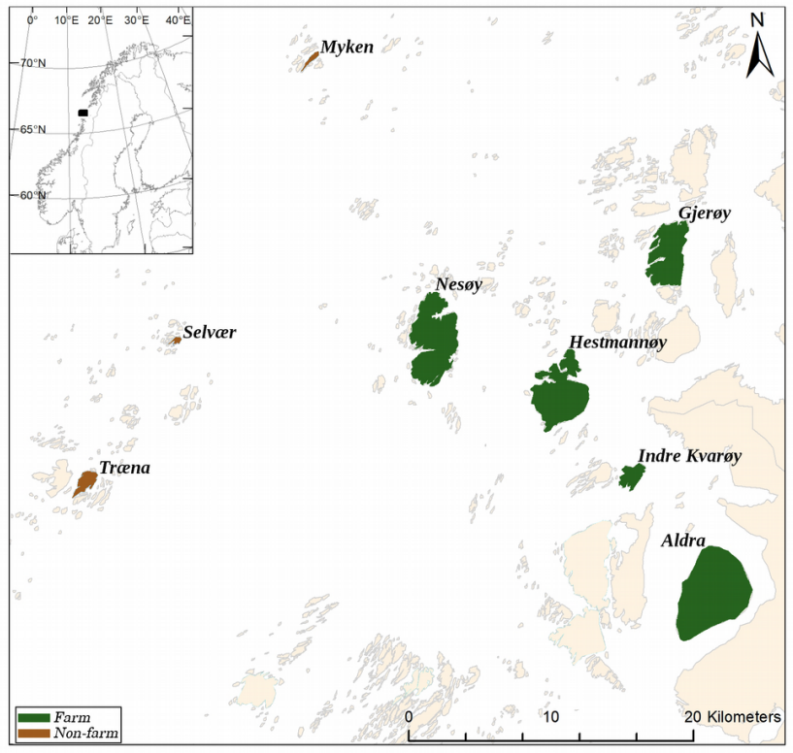

Figure 1. Map showing the house sparrow metapopulation study system in northern Norway.

Credit: Saatoglu et al 2023

We will use the package *marked* (Laake et al 2013a) in the program R to estimate apparent survival (referred to as survival) in this house sparrow meta-population. This package uses a similar syntax to another package called *RMark* (Laake et al 2013a) which is used to interface with Program MARK, the most widely used CMR software (White & Burnham 1999). MARK isn’t easily compatible with all operating systems making it unsuitable for a practical class like this. However, if you are interested in this topic, you might find the resources available on this website useful: <http://www.phidot.org/software/mark/index.html>. In particular, the freely available book *Gentle intro to MARK*: <http://www.phidot.org/software/mark/docs/book/>. Finally, we will perform goodness-of-fit tests using the package *R2ucare* (Gimenez 2018).

Lebreton JD, Burnham KP, Clobert J, Anderson DR (1992) Modeling survival and testing biological hypotheses using marked animals: a unified approach with case studies. Ecological monographs 62(1): 67-118.

Ringsby TH, Saether BE, Tufto J, Jensen H, Solberg EJ (2002) Asynchronous spatiotemporal demography of a house sparrow metapopulation in a correlated environment. Ecology 83(2): 561-9.

Laake JL, Johnson DS, Conn PB (2013a) *marked*: an R package for maximum likelihood and Markov Chain Monte Carlo analysis of capture–recapture data. Methods in Ecology and Evolution 4(9): 885-90.

Laake, J. L. (2013b). *RMark*: An R interface for analysis of capture-recapture data with MARK. Seattle, WA: Alaska Fisheries Science Center, National Marine Fisheries Service, NOAA.

White GC, Burnham KP (1999) *Program MARK*: survival estimation from populations of marked animals. Bird study 46(1): S120-39.

Gimenez O, Lebreton JD, Choquet R, Pradel R (2018) *R2ucare*: An R package to perform goodness-of-fit tests for capture-recapture models. Methods in Ecology and Evolution 9(7) 1749-1754.